

DATA STRUCTURES VISUALIZATION
CS163
SOLO PROJECT REPORT
Lecturer:
Dr. Dinh Ba Tien
Teacher Assistants:
M.Sc Ho Tuan Thanh
M.Sc Truong Phuoc Loc
Report Prepared and Written by:
Tran Phuoc Hai – 23125033

TABLE OF CONTENTS

INTRODUCTION [PAGE 2]

METHODS [PAGE 2]

RESULT [PAGE 4]

DISCUSSION [PAGE 6]

CONCLUTION [PAGE 8]

A. INTRODUCTION

Data structures are fundamental components in computer science that are essential for effectively managing and organizing data. Comprehending these structures is crucial for resolving intricate issues, refining algorithms, and augmenting the general efficiency of software programs. But it can be difficult to understand the complex relationships and actions found in data structures, especially for newcomers. In response, data structure visualization tools have become indispensable teaching aids that let experts and learners alike engage with and see the inner workings of these ethereal ideas.

This project aims to create a comprehensive data structure visualization tool that will give users an interactive, readable depiction of several types of data structures, including Heaps, Trees (AVL Tree, 234 Tree and Trie), Graphs, and Hash tables. The technology attempts to close the gap between theoretical knowledge and practical comprehension by letting users see how these structures are altered in real-time, which will make learning more natural and interesting.

The design and development process of the visualization tool will be described in this paper, along with a discussion of its main attributes, technical difficulties, and pedagogical implications for data structure studies. Our goal is to improve the teaching and learning of data structures by providing the academic community with a useful resource through this initiative.

B. METHODS

NUMBER | EMPLOYED METHODS | DETAILS
1 | PROGRAMMING LANGUAGE – C++ | C++ was chosen because it is the primary programming language taught in our curriculum. Its familiarity, along with its strong performance and control over system resources, made it a suitable choice for implementing the data structure visualization tool.
2 | SIMPLE AND FAST MULTIMEDIA LIBRARY (SFML) | For this project, I used the Simple and Fast Multimedia Library to program in graphics. Users might see dynamic structural changes because to the library's real-time animations for operations like insertion and deletion. Because of SFML's adept handling of 2D images, it was a good choice for developing a visually appealing and responsive educational tool.
3 | OBJECT-ORIENTED PROGRAMMING | Object-oriented programming (OOP) was used to manage classes effectively. This approach allowed for clear organization of code, encapsulation of data, and reuse of components, making the implementation of complex data structures and their interactions more manageable and maintainable.
4 | CMAKE | CMake was used to generate the executable file. It provided an efficient way to manage the build process, configure the project, and handle dependencies, ensuring smooth compilation and linking of the C++ code into a final executable.
5 | INTEGRATED DEVELOPMENT ENVIRONMENT:  VISUAL STUDIO 2022 | The project was developed in Visual Studio 2022. This environment provided a comprehensive IDE with powerful debugging and code management tools, facilitating the development and testing of the C++ application. CMake was used within Visual Studio to configure and generate the executable file.
6 | VERSION CONTROL SYSTEM:  GIT HUB | GitHub serves as a platform for Git version control and teamwork. In addition to facilitating code review and project management, it hosts Git repositories and enables branching, merging, and pull requests. It makes it possible to collaborate with others, track changes, and automate workflows.  Git Repository URL: https://github.com/Zickkey84/Data-Structure-Visualization
7 | DOCUMENTATION AND GUIDES | > I used the book SFML Game Development for this project to have a thorough understanding of SFML and its features.  > The practical insights and visual demonstrations provided by YouTube training videos were very helpful in understanding how to integrate graphics and manage data structures.  > I also looked up comprehensive technical references in the API documentation for graphics libraries to make sure my coding was precise and efficient.  > I also received guidance from senior students, which provided practical advice and insights based on their experience.

C. RESULT

The project successfully developed a data structure visualization tool, with two main outputs:
- Main Screen: The main screen provides an overview of the application, featuring a menu for selecting different data structures and operations. It serves as the central hub for navigating through the tool’s functionalities.
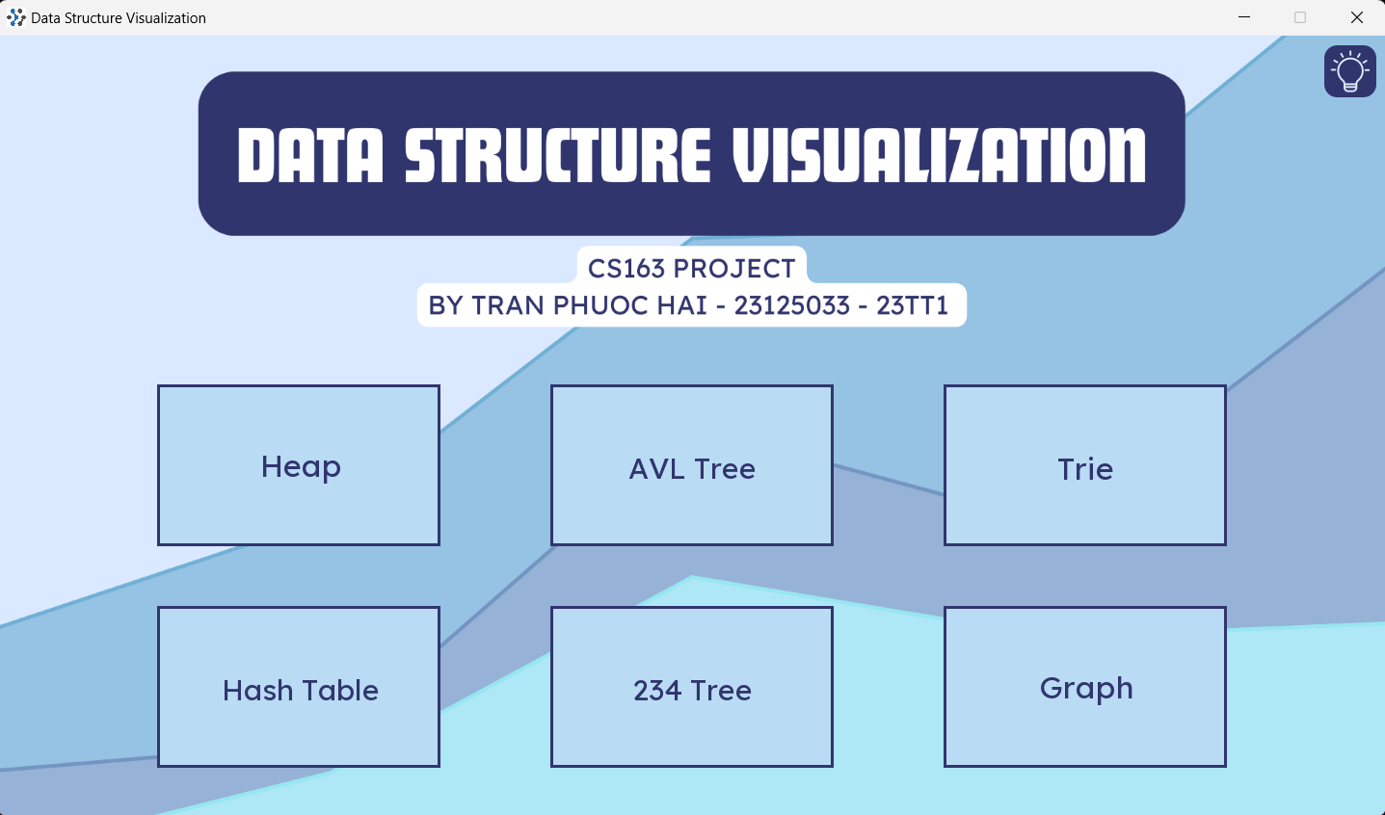
Figure 1: Main Screen
In addition, users can toggle between light and dark modes for enhanced usability and comfort, depending on their preferences or lighting conditions.
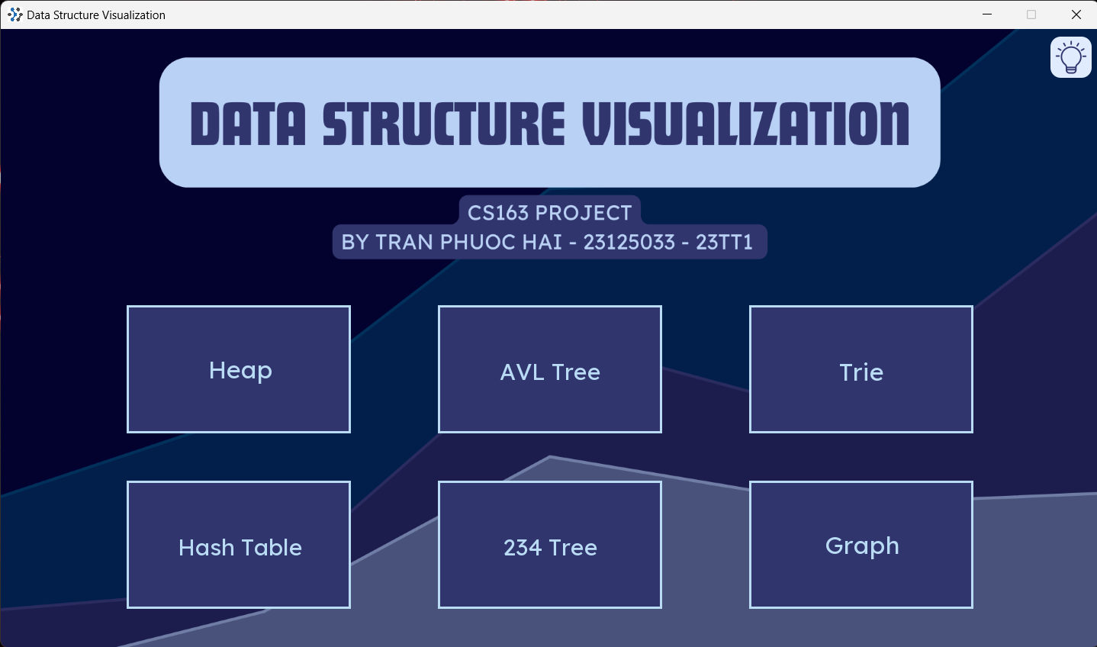
Figure 2: Main Screen in Dark Mode
- User Interface Screen: This screen displays the interactive visualization of data structures. It shows real-time animations of operations like insertion, deletion, and traversal, allowing users to explore and understand the dynamics of various data structures.
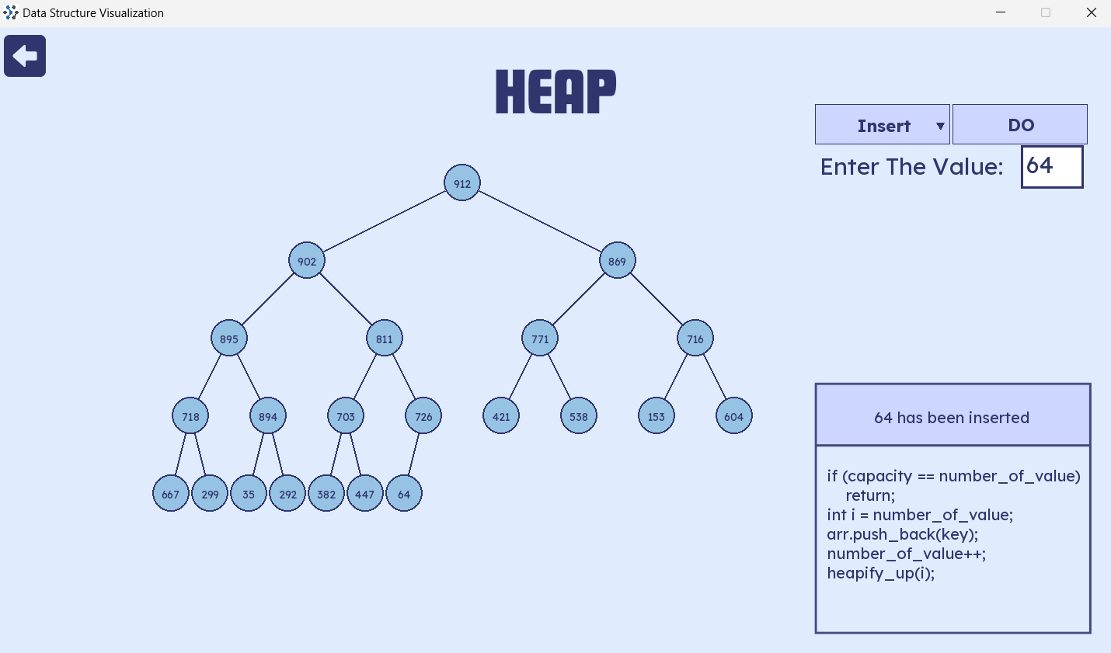
Figure 3: User interface screen in Light Mode

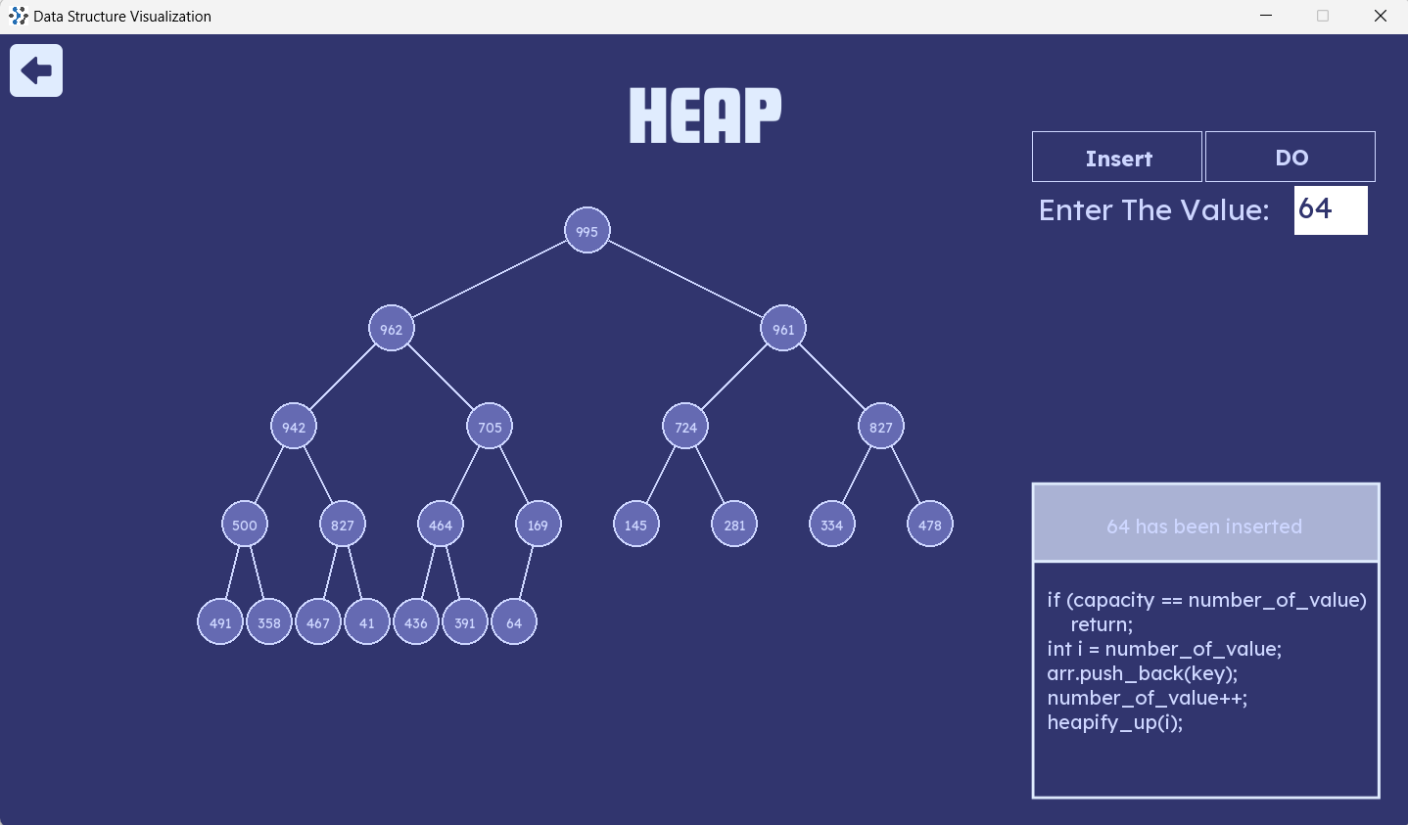
Figure 4: User interface screen in Dark Mode

Main features of the application:
- Hash Table: Visualizes basic operations such as create, insert, delete, and search.
- Heap: Includes operations like create, insert, delete, search, get top and get size.
- AVL Tree: Visualizes creation, insertion, deletion, and searching.
- 234 Tree: Supports visualization of create, insert, delete, and search operations.
- Trie: Displays basic operations including create, insert, delete, and search.
- Graph: Visualizes basic operations and includes algorithms for counting the Connected components and finding the Minimum spanning tree.

D. DISCUSSION

- Challenges
  - Complexity of Visualization: Visualizing data structures step-by-step was challenging due to the complexity of synchronizing animations and maintaining real-time updates. Ensuring that each step accurately reflected the operations while keeping the interface responsive required careful management of rendering and timing.
  - Performance Issues: Managing several data structures and associated animations at once can occasionally cause performance problems, especially when dealing with bigger data sets or more intricate procedures.
  - Documentation and Tutorials: While books, tutorials, and API documentation were useful tools, integrating and using them in a project effectively required a learning curve and occasionally caused delays.

- Limitations
  - Step by step Visualization: The tool does not support step-by-step visualization for heaps, graph, AVLTree (insert and delete) and 234Tree (insert and delete).
  - Scalability: Data structures are not optimized for handling large datasets, with a maximum size limit affecting performance and visualization accuracy.
  - Incomplete Features: Some functions are still under development and not fully integrated.

- Class and File Organization
There will be files to manage states class, as shown in the figure below
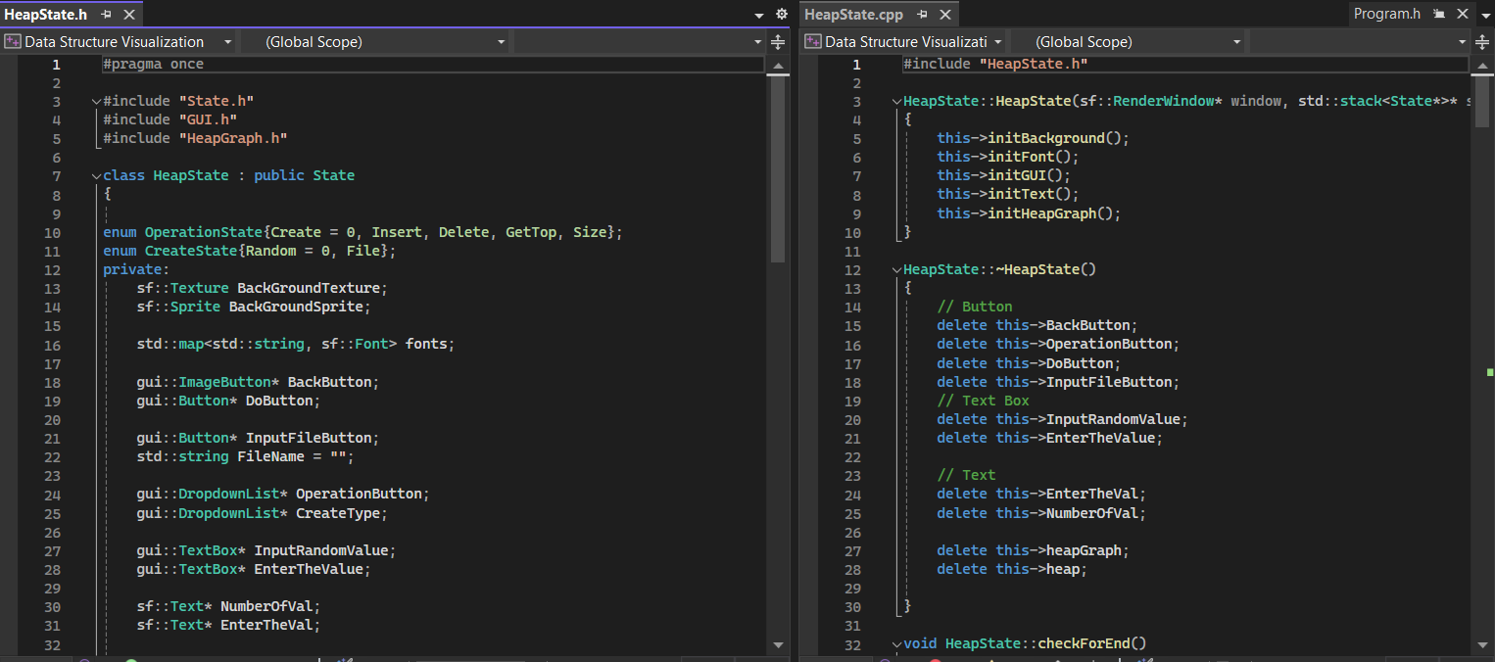
Figure 5: HeapState File

The MainMenuState file will include the states for the data structures.
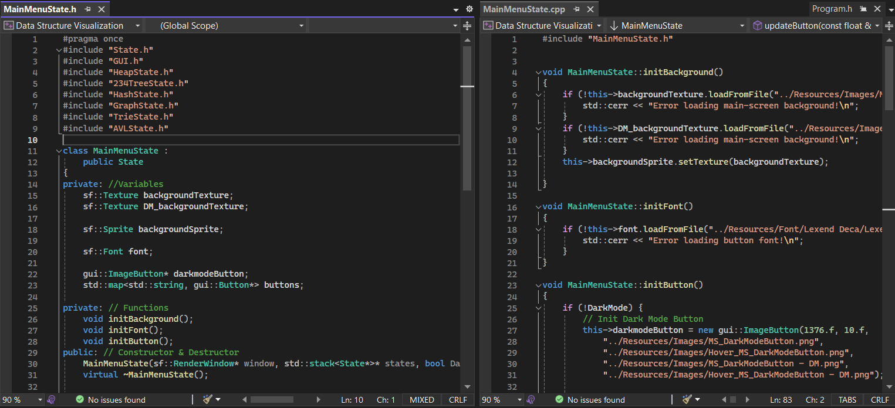
Figure 6: MainMenuState File

Each data structure will include the following files for visualization:
- State: Manages the state of the data structure.
- Algorithm: Contains the implementation of algorithms related to the data structure.
- DataStructureGraph: Handles the graphical representation and visualization of the data structure.
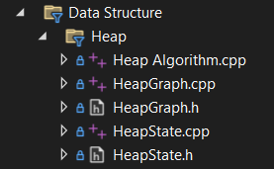
Figure 7: Files for visualization
Additionally, there will be utility files for:
- GUI Components: Managing UI elements like buttons, text boxes, etc.
- TreeNode: Drawing the nodes of tree
- Color: Storing color schemes.
- Functions: Including utilities for random number generation, file dialogs, etc.
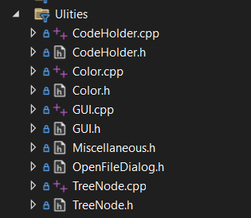
Figure 8: Utility files

E. CONCLUSION

This project created a data structure visualization tool that included Hash Tables (using Linear Probing for resolving the colisions), Heaps (max heap), AVL trees, 2-3-4 trees, Trie, and Graphs. The application provides interactive visualizations with real-time animations, supports both light and dark modes, and features key operations for each data structure, such as creation, insertion, deletion, and search.

While there were difficulties, notably in implementing step-by-step visuals and managing big datasets, the tool is an invaluable instructional resource. Future enhancements will focus on improving performance, adding capabilities, and completing ongoing development to improve the user experience.
I appreciate the instructors for their help and support during the endeavor. Their suggestions and encouragement were critical in overcoming obstacles and meeting the project's objectives.

